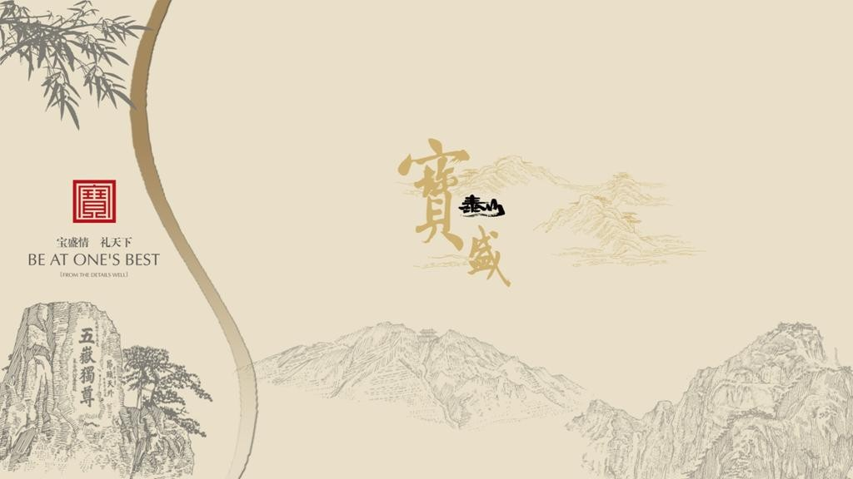

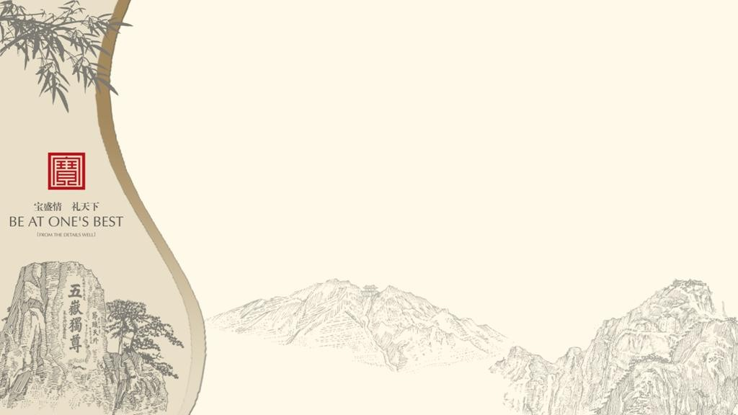
泰安简介 | City Introduction
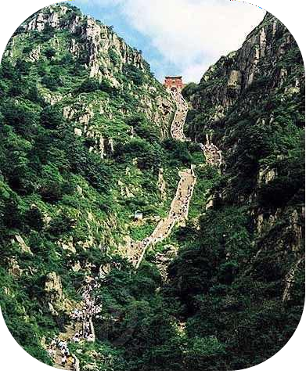
泰山坐落于泰安城北， 是我国的“五岳”之首， 有“天下第一山”之美誉， 又称东岳， 中国最美的、 令人震撼的十大名山之一, 是世界自然文化遗产。 泰安从“泰山安则四海皆安”一语中来， 取意国泰民安。 泰山也是3000多年来中国历代帝王最重要的封禅祭祀的圣地。 孔子留下了“登泰山而小天下”的赞叹， 杜甫则留下了“会当凌绝顶， 一览众山小”的千古绝唱。
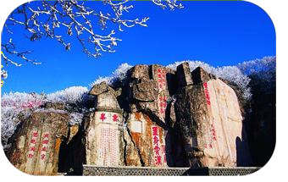
Taishan is located in the north of the city of Tai'an, is China's "Five" first name "the best in all the land, also known as Dongyue mountain, one of the ten most beautiful mountains China, shocking, is the world natural and cultural heritage. Tai'an from Taishan is an universal "phrase, the meaning of peace. Taishan is more than 3000 years Chinese emperors worship shrine is the most important. Confucius left the "Mount Taishan and the world" praise, Du Fu left "would be extremely Ling, list of small hills," the poetic masterpiece through the ages.
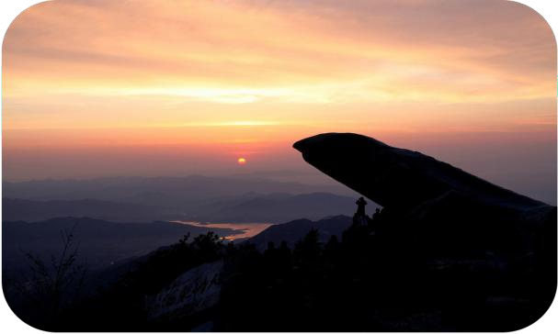

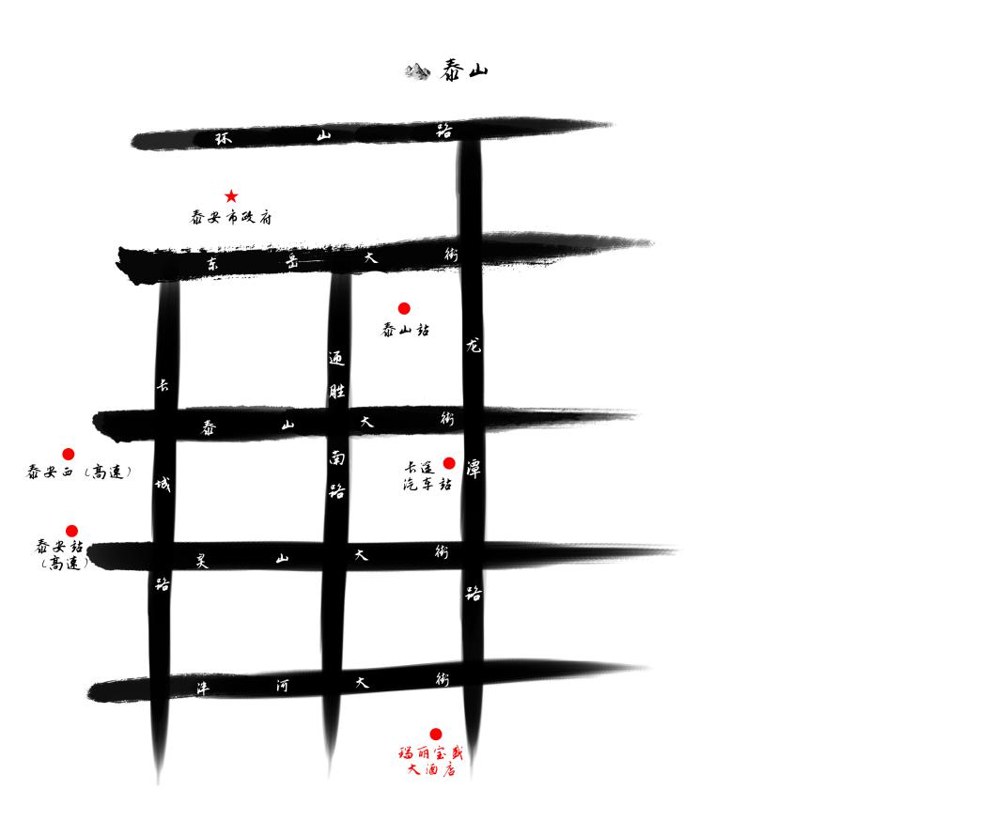优越的地理位置 | Ideal Location

距泰安高铁站： 20分钟汽车车程
From/To Taian Railway Station: 20 min by Car

距泰山进山口： 15分钟汽车车程
From/To Entrance of Mt Tai: 15 min by Car

距曲阜高铁站： 20分钟高铁车程
From/To Qufu Railway Station: 20 min by High-speed Rail

距济南高铁站： 18分钟高铁车程
From/To Jinan Railway Station: 18 min by High-speed Rail

距济南遥墙国际机场： 90分钟汽车车程From/To Jinan airport: 90 min by Car

酒店提供豪华轿车及中巴车租赁服务，方便接送客人。
Hotel provides coach facilities to pick up and drop off guests

酒店简介| Hotel Introduction
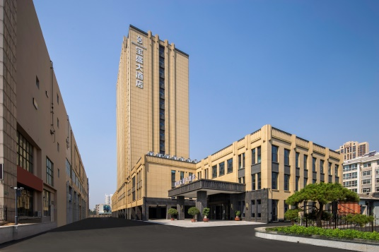
山东瑞丽宝盛大酒店是按五星级标准设计装修，座拥秀丽景致的泰山脚下，毗邻泰安国际会展中心，距离泰安高铁站及泰安高速口20分钟可达。
酒店总建筑面积3万平方米左右，装修以古典新中式为基调，现代与古韵的 完美结合，高端大气、彰显尊贵。酒店拥有200间豪华客房/套房，6个大中小型会议场地，是国内外宾朋进行商务、旅游、会议、休闲的最佳择地。
Shandong Ruili Blossom Hotel is based on the design and decoration of Five-star Standard,The hotel is located at the foot of the scenic Mount Tai,close to the Tai'an international Convention and Exhibition Center and twenty-minute ride to Tai'an High Railway Station and Tan'an high-speed toll.
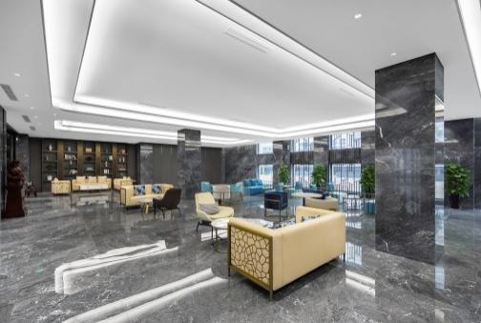
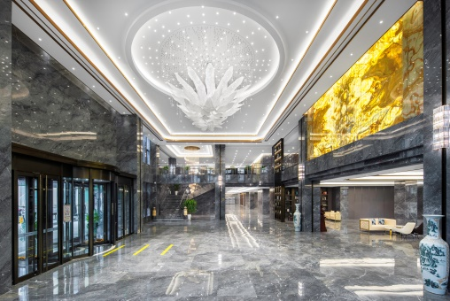
The gross floor area of this hotel is 30000㎡,and its decoration in the new Chinese classical style combines perfectly of modern and ancient,creates dignity,manifests nobility.There are 200luxury guest rooms/suites and 6 large-,medium-and small-scaled conference rooms,and it is the best choice for the domestic and foreign guests for their business,tourism,conference and leisure.

会议与宴会 | Conference and Banquet
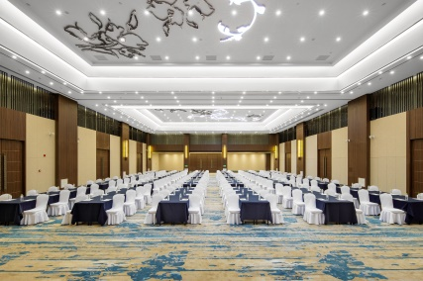
酒店拥有800m²无柱、层高8.5米的多功能厅，可容纳剧院式700人会议， 宴会用餐40桌,为宾客多元化及灵活性的会议需求提供最大的便利。1个500m²宴会厅配套使用，并设有风格独特大中小型会议室6个供您选择！
The hotel has a multi-function hall with the area of 800
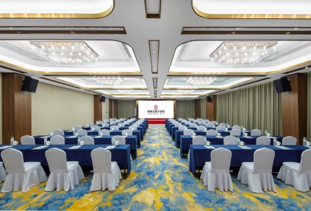
㎡ ,8.5-meter height and no piillars.It can hold 700-person theater-style conference,banquet dining tables 40 ,to provide the maximum conveninece for the guests of the meeting the demand diversification and flexibility.One 500 ㎡ banquet hall and 6 conference halls with siverse style in small,medium and large size are equipped to satisfy your any conference needs!

V会议与宴会| Conference and Banquet
容纳人数
名称 | 面积（平方米）  Area(㎡) | 层高（米)  Ceiling Height(m) | 课桌式  Classroom | 口字型  Mouth shape | 回字形  Back font | 剧院式  Theater | 宴会式  Banquet | 岛屿式  Island
宝盛厅 | 800 | 8.5 | 400 | / | / | 1000 | 400 | 400
宝盛1 | 400 | 8.5 | 200 | / | / | 400 | 200 | 200
泰山厅 | 500 | 4 | 280 | / | / | 500 | 240 | 240
齐风厅 | 280 | 4 | 160 | / | / | 280 | 180 | 150
高鹏阁 | 150 | 4 | 70 | / | / | 120 | 100 | 90
鲁韵厅 | 200 | 4 | 100 | / | / | 220 | 120 | 90
贤士阁 | 100 | 4 | 50 | / | // | 100 | 100 | 60

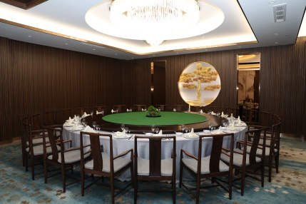
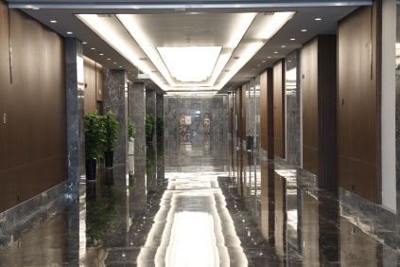
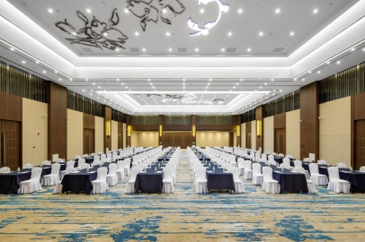
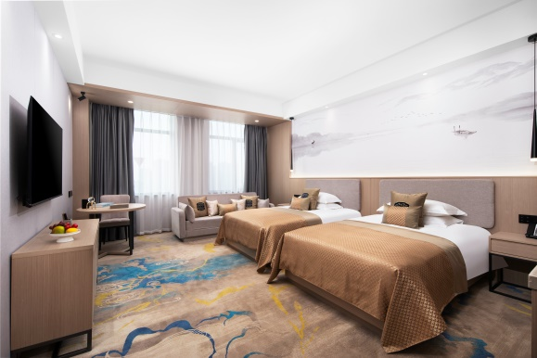
客 房 | Gusets Room
酒店拥有200间豪华客房，354个床位，其中2间设计豪华的行政商务套房，面积均超过85m²以上，标准商务客房41m²以上，从客房可尽览泰山的雄伟风光及泰城全貌。
The hotel has 200 Luxury guest rooms and 354 beds，including 2 deluxe-designed excurive business suites over 85 ㎡ ． All the standard business rooms are largger than 41 ㎡ ， and overlooking a magnificent view of Mount Tai and the whole Tai'an City.
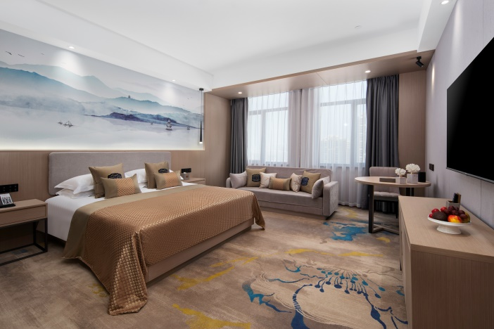

餐饮服务 | Catering service
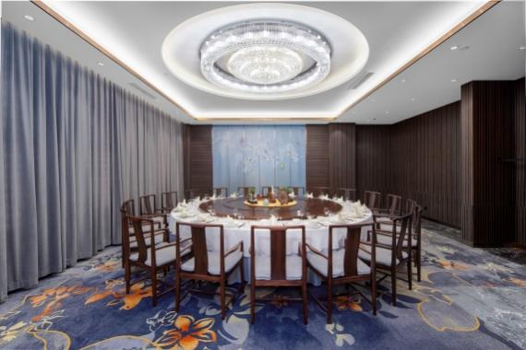
瑞丽宝盛大酒店拥有中、西宴会餐厅3个，豪华餐饮包间23间，可同时为550位宾客提供餐饮服务。中餐厅主要向宾客提供杭邦特色菜、鲁菜及中高 档海鲜，能让您充分领略南北美食的文化精髓。
There are 3 Chinese and Western banquet halls and 23 deluxe dining rooms in Taishan Blossom Hotel,which can cater for 550 guests at the same time.
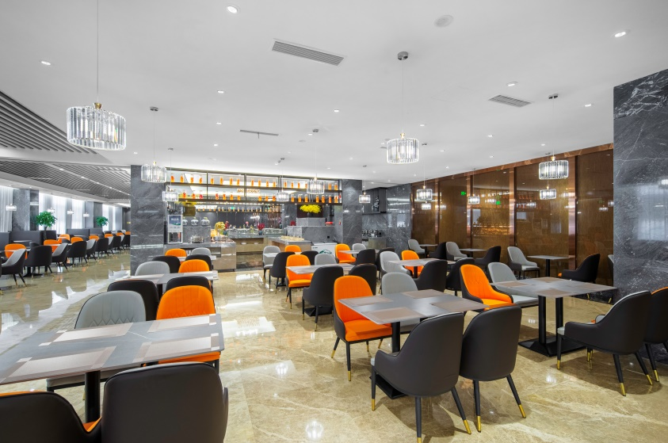
Chinese banquet hall mainly offers Hangzhou specialties,Shandong cuisine and high-grade seafood for guests and allows you fully appreciatte the cultural essence of north and south cuisine.

休闲娱乐 | Leisure and entertainment
酒店配有棋牌、足浴、儿童乐园、健身中心、KTV等娱乐设施供您休闲娱乐！
The hotel is equipped with chess and cards room,foot massages center,children's palyground,fitness center,KTV and other entertaiment facilities to satisfy your leisure and enterrainment needs.

泰安旅游景点 | Taian Tourist Attractions

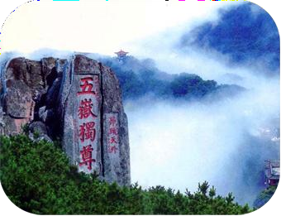
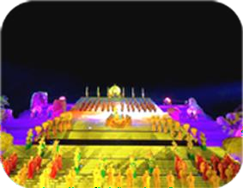
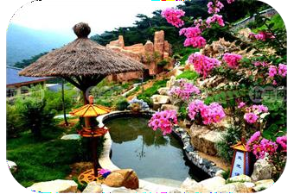

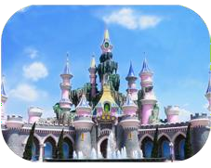

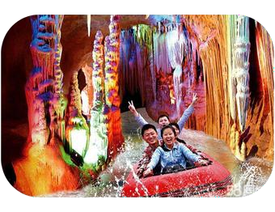
方特欢乐世界
泰山温泉城
Mount Tai Hot Spring City
封禅大典实景演出Grand Worship of Heaven and Earth about Mt Tai
泰山风景区
Mt Tai Scenic Area
Fanta Wild Adventure
太阳部落Sun Tribal
地下大裂谷Underground Rift Valley

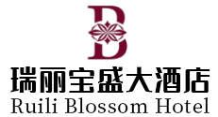

联系人：赵清伟 18766119130
地址：山东省泰安市泰山区龙潭路213-1号
Address: 213-1 Longtan Road, Taishan District, Tai'an, Shandong

